Abstract—This paper sequentially examines (1) the definition of methodology, (2) the classification of methodology, and (3) how to think methodologically. Methodology is defined as an orderly sequential and systematical step by step process to reach out our purpose. In terms of research, research methodology means an orderly sequential and systematical step by step process to answer the research’s questions (research’s purposes). Methodology is classified into 3 categories, they are (1) Conceptual Methodology, (2) Collectical Methodology, and (3) Statistical Methodology. In order to be able to Think Methodologically, it is very crucial that we need to understand precisely on how to (1) Think Analytically, (2) Think Synthetically, and (3) Think Systematically.
A Proposal for Mapping the Methodology and How to Think Methodologically
Muhammad Hafizhurrahman
Martapura, Kabupaten Banjar, Kalimantan Selatan
blog: www.freedomengineersnotes.blogspot.com
e-mail: mhafizhurrahman@gmail.com
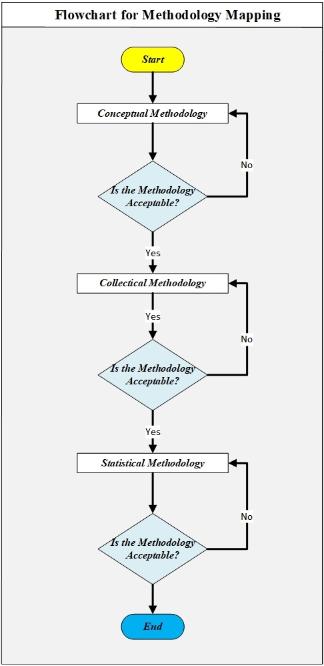
Figure 1. Flowchart of an orderly sequential and systematical step by step process for Methodology Mapping.

Keywords—The definition of methodology, the classification of methodology, how to think methodologically.

METHODOLOGY

Definition of Methodology
Methodology is an orderly sequential and systematical step by step process to reach out our purpose. Methodology is all about the process, it is all about the how to do. In terms of knowledge, methodology means an orderly sequential and systematical step by step process to gain knowledge. In terms of research, research methodology means an orderly sequential and systematical step by step process to answer the research’s questions (research’s purposes), to sum up, it is all about how to do the research in order.

Classifications of Methodology
Methodology can be classified into 3 categories, they are (1) Conceptual Methodology, (2) Collectical Methodology, and (3) Statistical Methodology. Figure 1 shows the sequential step by step flowchart for the mapping of Methodology.

2.1. Conceptual Methodology
Conceptual Methodology is a methodology that focus on how to plan and organize the research step by step sequentially and systematically in order. Conceptual Methodology consists of 4 elements, they are (1) the purposes of research, (2) the outputs of the research, (3) the methods to do the research, and (4) the inputs that are needed for the research. The visualization of Conceptual Methodology’s flow of thinking can be seen on Figure 2.

2.2. Collectical Methodology
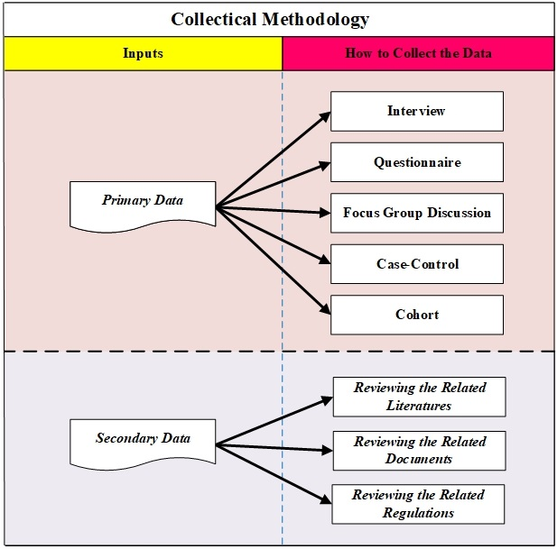
Figure 3. Collectical Methodology that divided into 2 categories, which are (1) how to collect the primary data and (2) how to collect the secondary data.
Collectical Methodology is a methodology that focus on how to collect the data as inputs for the research. Collectical Methodology can be classified into (1) how to collect the primary data and (2) how to collect the secondary data. Firstly, regarding on how to collect the primary data, there are 5 methods, they are (1) interview, (2) questionnaire, (3) focus group discussion, (4) case-control, and (5) cohort. Secondly, in order to collect the secondary data, there are 3 methods, they are (1) reviewing the related literatures, (2) reviewing the related documents, and (3) reviewing the related regulations. The visualization of Collectical Methodology’s flow of thinking can be seen on Figure 3.
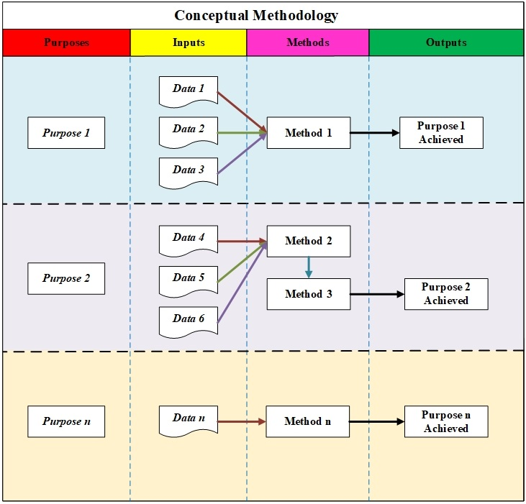
Figure 2. Conceptual Methodology that consists of (1) the purposes of research, (2) the outputs of the research, (3) the methods to do the research, and (4) the inputs that are needed for the research.

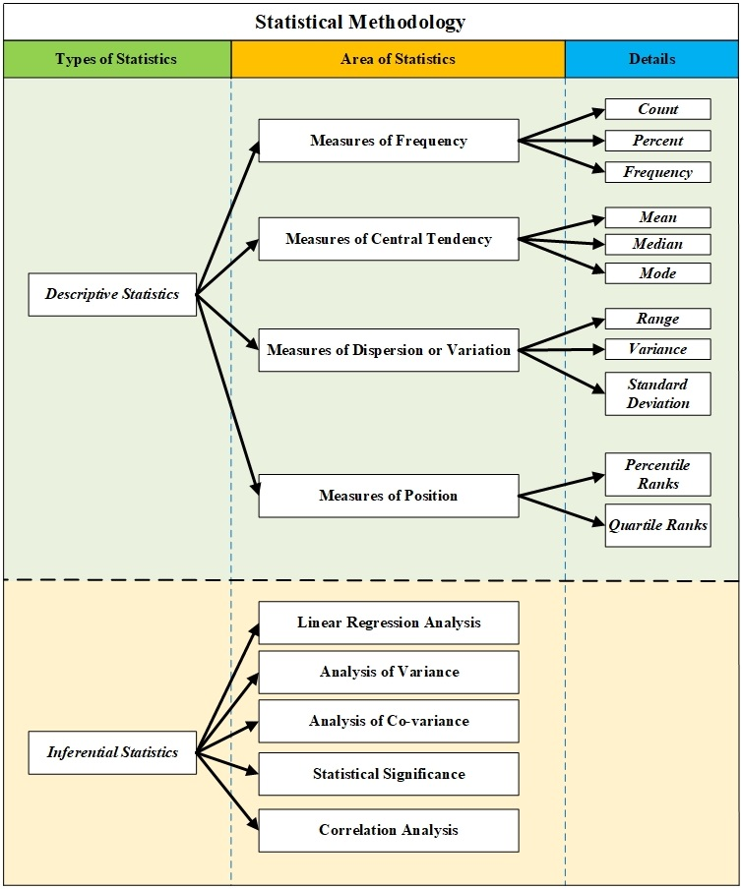
Figure 4. Statistical Methodology or we can called as Statistics divided into (1) Descriptive Statistics and (2) Inferential Statistics.

2.3. Statistical Methodology
Statistical Methodology is a methodology that focus on how to analyze the empirical data and interpret the result of the analyzes to conclusion. Statistical Methodology can be called as Statistics. Statistics can be classified into 2 categories, they are (1) Descriptive Statistics and (2) Inferential Statistics. Statistical Methodology (Statistics) including descriptive statistics and inferential statistics can be seen on Figure 4.

2.3.1. Descriptive Statistics
Descriptive statistics is statistics that is used for describing population. According to how we use the statistics, descriptive statistics can be classified into 4 catagories, they are (1) if the statistics is used for measuring frequency (count; percent; and frequency), (2) if the statistics is used for measuring central tendency (mean; median; and mode), (3) if the statistics is used for dispersion or variation (range; variance; and standard deviation), and (4) if the statistics is used for measuring position (percentile ranks; quartile ranks).

2.3.2. Inferential Statistics
Inferential statistics is statistics that is used for testing and predicting. Descriptive statistics in general can be classified into 5 catagories, they are (1) linear regression analysis, (2) analysis of variance, (3) analysis of co-variance, (4) statistical significance, and (5) correlation analysis.

HOW TO THINK METHODOLOGICALLY

Definition of Thinking Methodologically
Thinking methodologically means thinking that is governs by sequential, systematical, and disciplined order. There are 3 thinking abilities that are needed in order to be able to think methodologically, those abilities are (1) the ability to think analytically, (2) the ability to think synthetically, and (3) the ability to think systematically.
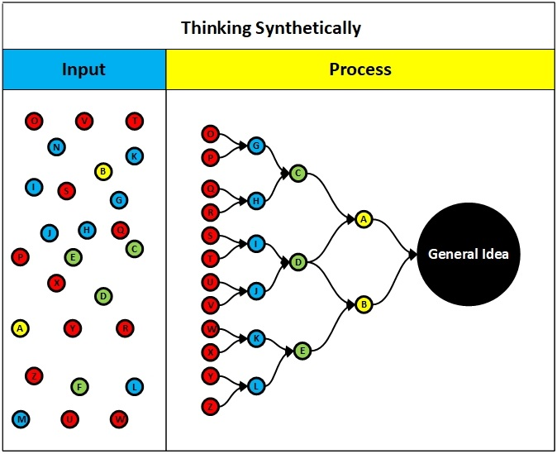
Figure 7. How to think synthetically.

Thinking Analytically
Thinking analytically means thinking by breaking down the elements of thinking. Instead of Thinking Analytically, we can use other nomenclatures such as (1) Thinking Deductively, (2) Thinking Divergently, (3) Thinking Sequentially, and (4) Thinking Chronologically. They are all the same because they have the same meaning. How to think analytically can be seen in Figure 5 and the example of the implementation of thinking analytically can be seen in Figure 6.

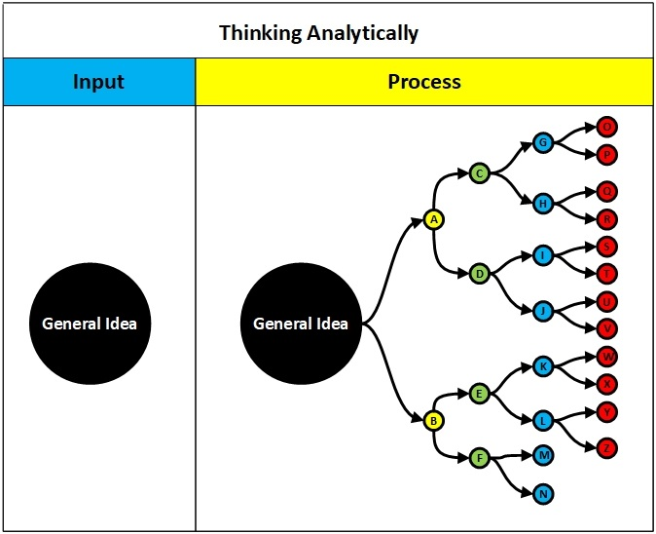
Figure 5. How to think analytically.
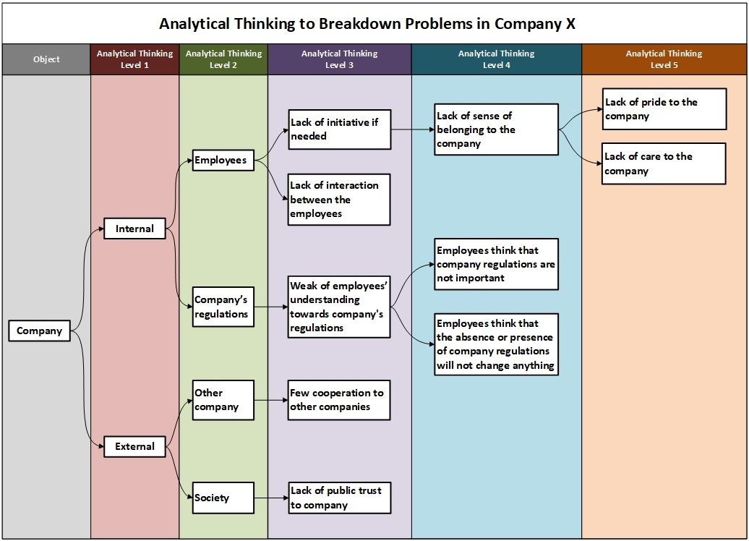
Figure 6. Example of the implementation of thinking analytically.

Thinking Synthetically
Thinking synthetically means thinking by combining the elements of thinking. Instead of Thinking Sythetically, we can use other nomenclatures such as (1) Thinking Inductively and (2) Thinking Convergently. How to think synthetically can be seen in Figure 7.

Thinking Systematically
Thinking systematically means thinking by breaking down the elements of thinking and recognise the cause and effect then draw its correlation and causation. Instead of Thinking Systematically, we can use other nomenclatures such as (1) Thinking Holistically and (2) Thinking Comprehensively. How to think systematically can be seen in Figure 8 and the example of the implementation of thinking systematically can be seen in Figure 9, Figure 10, and Figure 11.
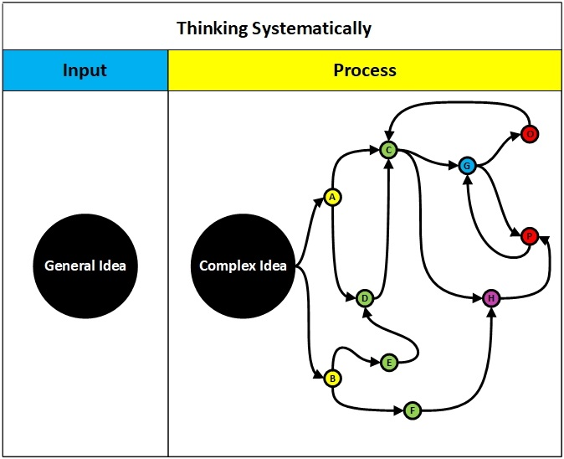
Figure 8. How to think synthetically.

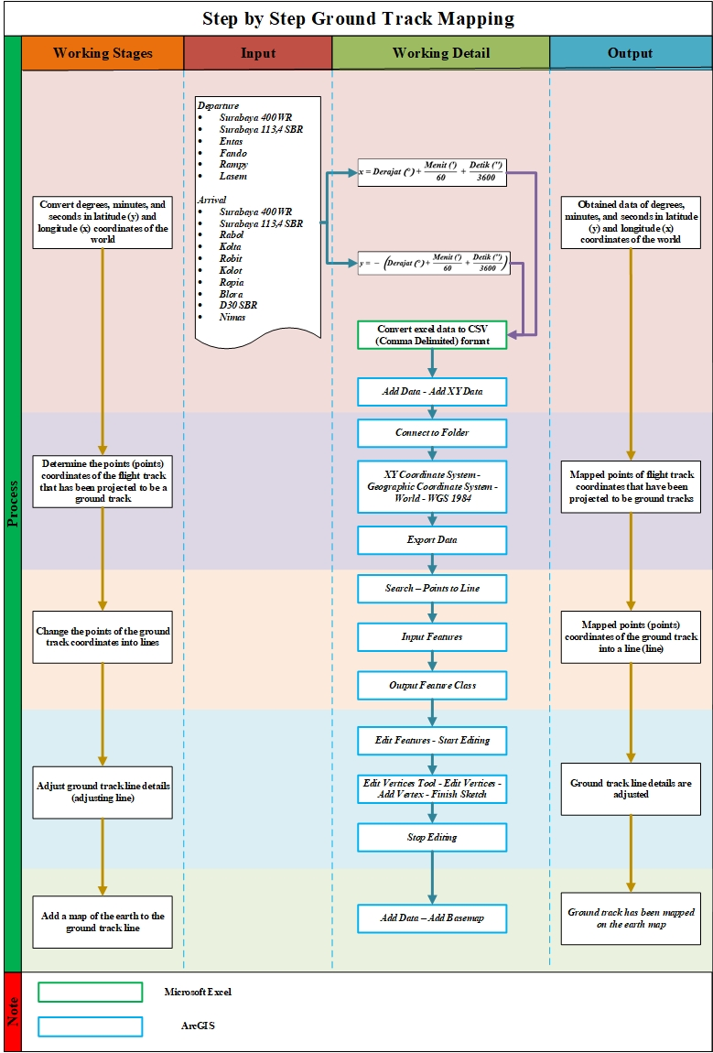
Figure 11. Example of the implementation of thinking systematically.

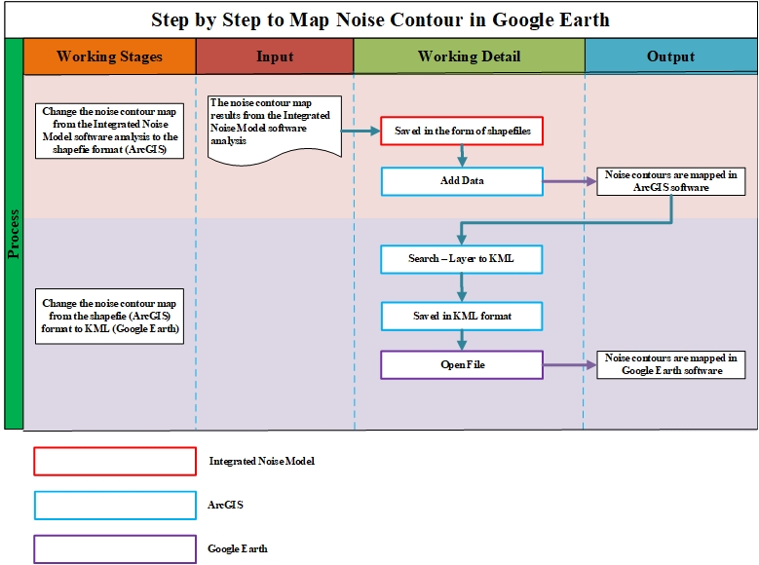
Figure 10. Example of the implementation of thinking systematically.
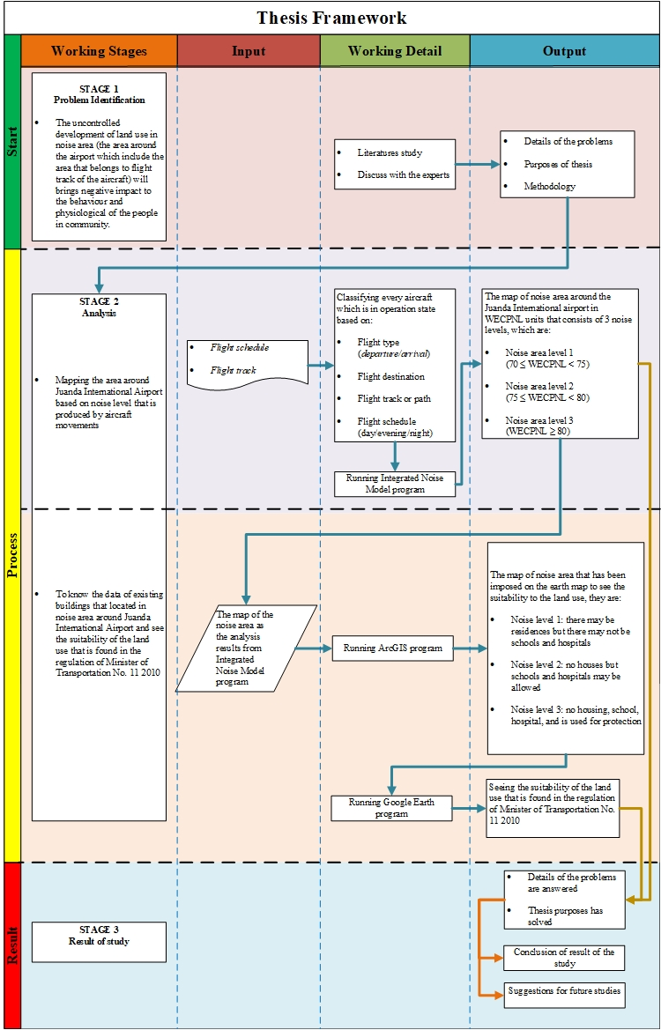
Figure 9. Example of the implementation of thinking systematically.

